Galerie La Ferronnerie
40, rue de la Folie-Méricourt F-75011 Paris
tél/fax : 00 33 (0)1 48 06 50 84
www.associationdesgaleries.org/laferronnerie
du mardi au vendredi : 14h-19h, samedi : 13h-19h
Membre du Comité Professionnel des Galeries d’Art

We would be honoured to welcome you
in Galerie la Ferronnerie for the upcoming show

SANNA KANNISTO

Tangle*
*enchevêtrement

Vernissage Tuesday May, 30th 18h30 to 22h00
Exhibition from May 30th till July, 8th 2006

Sanna Kannisto ( born in 1974, Hameelina, Finland) will propose, for Tangle exhibition, a new series
of photographies, mostly realised in La Selva Biological Station, Costa Rica, 2004- 2005. This work is a
continuation of the series Private Collection, where she was presenting photos of staged elements taken
from the flora and fauna of the Amazon ; With Tangle, focus will be on panoramic, mystifying approach in
landscapes, as well as an attempt to capture the movement of Hummingbirds…

Extracts from Mika Hannula’s text, in catalogue Self-timer/ Selbstauslöser, exhibition in
Kunstalle Fridericianum Kassel, 21.12.05/26.02.06

‘…What Sanna Kannisto does it to reverse the view. She is not looking from personal towards the public,
but from personal notions towards detail of our ecosystem. In fact, she orchestrates specific views of
the flora and fauna of Amazon; ..What I see is carefully staged views onto the unknown world. It is not
the whole,but the details. She relocates the plants from their natural environment to the studio setting,
and thereby she makes them singular. ..Sanna makes visible some of the magic that is there; magic
to which we normally have no access. The hope consists in being able to notice that there is so much
we do not know, that we do not have the capacity to cherish and acknowledge. In this case this consists
in those specific phenomena within our ecosystem that are unfortunately disappearing, but which are with
us still. There is a hope filled with sadness, and with loss..’

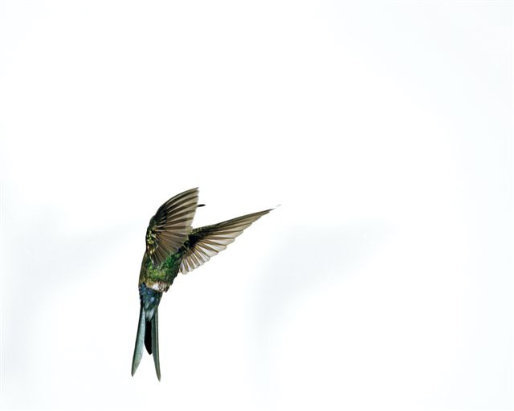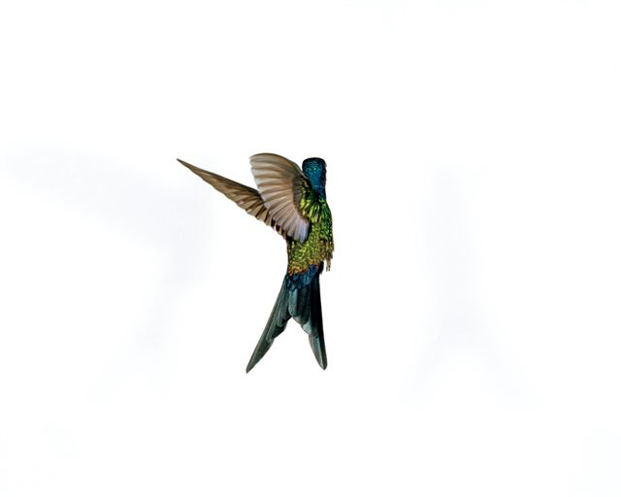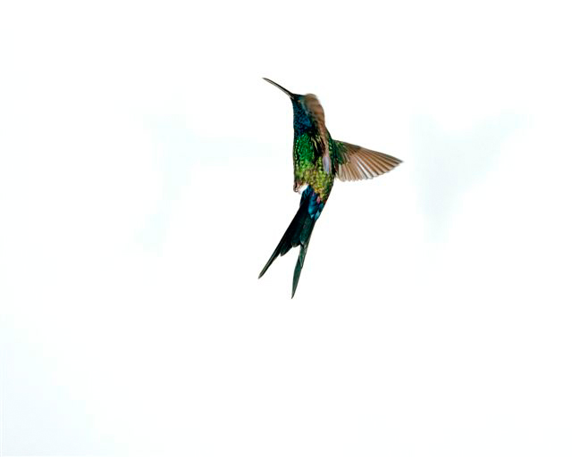

Hummingbird flight, Thalurania glaucopi, 2005, Diasec, 44cmx56cm chaque

Harri Laakso*, about the series ‘Hummingbirds flight, Thalurania glaucopis’,

‘The series acts at the limits of the photography in at least two significant ways : the small bird challenges
the framing as well as the speed of the image. I believe that this images also put to the test photography’s
ability to faithfully reproduce the tones of the tiny wings, even if the wing strokes strokes and flight patterns
are mapped against the invisible coordonnates of a white space, which offers the bird full attention.
Studies of motion hold an important place in the history of photography as images that reveal things which
Ordinary Sight could not perceive. The starting point for their analysis is often the stopping of time, a
negation of movement.Motion studies are sculptural -they tell us more about potential movement
itself as a flowing event…’

*In catalogue to be continued…Helsinki Photography Festival 2005. Harri Laakso : Art Phd from Helsinki University

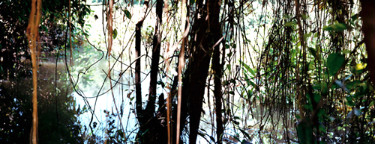

Tangle, 1997, Diasec, 2x75x94cm

Question from Birgit Eusterschulte* to Sanna Kannisto,
*curator, Self-timer/ Selbstauslöser, Kunsthalle Fridericianum Kassel

Does the theoretical thinking of Claude Lévi-Strauss and Michel Foucault have a special significance
for your work ? You mention Lévi-Strauss in several texts. In what way did his writings accompany the
development of a more conceptual approach in your work ?

I really don’t know the answer to this question. I very much respect and admire Claude Lévi-Strauss’s way
of explaining human behaviour and the irrational, and his work in South America. His idea of the
pensée sauvage fits well with artistic work because artists collect knowledge at the level of the sensory
perceptions and experiences. Pensée sauvage –the concrete logic- tries to create hierachies and a kind
of total understanding about the environment, unlike science, which divides a problem analytically into
as many small parts as are required to solve… …I rather see myself working like a Renaissance person
or a dilettante. Lévi-Strauss reminds us that people can apprehend the world by different means. I agree
with the French structuralists that scientific truths, cultural discourses and practices are open to argument
and to change.

Recent Exhibitions (selection)

2006 Tangle, Galerie La Ferronnerie, solo, Paris, France ; Jackson Fine Art, solo, Atlanta, U.S.A. ;
Galerie Tolksdorf, solo, Berlin ; Gallery F-Station, solo, Mois de la Photo à Cracovie, Poland (cat.) ;
Galleria K, Huittinen, Finland ; Bergen Kunsthall, Norway ; Repeat all, Vevey Switzerland ; Fokus Finland KBB,
Barcelona, Spain ; White Box, New York, U.S.A. ; Festival of Contemporary Art, Glasgov, Scotland ;
2005 Self-timer/ Selbstauslöser, Kunsthalle Fridericianum, Kassel, Germany (catalogue) ; Läsnäolo, Wäinö Aaltonen
Art Museum, Turku, Finland ; Paris Photo, Galerie van Zoetendaal, Galerie Taïk, Paris, France ; The Helsinki School,
Zagreb, Croatia ; Château de Chamarande, France; Helsinki School, Künstlerhaus Bethanien, Berlin, Helsinki
Photography Festival, Kunsthalle, Helsinki (catalogue) ; FRAC Haute-Normandie, Sootteville-les-Rouen, France ;
2004 Private Collection, Galerie La Ferronnerie, Paris, France (catalogue) Art Forum Berlin, Galerie La Ferronnerie,
Germany. 2002 Mina-sina-me, Institut Finlandais, Paris, France, (cat.) ; Finnish Institute in Madrid, Spain ;
Gallery Hippolyte, Helsinki, Finland (book) ; 2001 CuLTUR, Västerås, Sweden ; VB-Photographic Centre, Kuopio,
Finland ; Rantagalleria, Oulu, Finland ; 2000 Gallery of the Finnish Museum of Photography, Helsinki,
Finland (catalogue Photo.doc) ; Hyvinkää Art Museum, Hyvinkää, Finland ;

