Galerie La Ferronnerie
40, rue de la Folie-Méricourt
F-75011 Paris
www.galerielaferronnerie.fr

Laurent Fiévet

Essences de l'image,

portraits olfactifs
video installations

Vernissage: february 14th, 18.30 - 22.00
Exhibition: february 14th till march14th 2006

press release

The third part of Laurent Fievet's* study on A. Hitchcock's work, Essences de l'Image, portraits olfactifs
(Essences of Image, olfactive portraits), is a following up to the shows Epreuves du Temps (Tests of Time)**
and Suites hitchcockiennes (Hitchcock series, Continuations of Hitchcock) presented in Finland during
winter 2003-04, at the Hyvinkää Museum of Fine Arts (14/11/03-1/02/04) and Kiasma, Helsinki Contemporary
Art Museum (18/12/03 - 29/02/04). The project is based on the artist's research -he is a Ph.D in film studies-
an aims, through artistic installations, to create a relation between some shots from A. Hitchcock's films and
some famous paintings which could have inspired them.
*born 1969, Boulogne Billancourt-Paris, France
**The Epreuves du Temps exhibition will be presented at the Paris Institut Finlandais during autumn 2006.

Essences de l'Image is built around the olfactive presences worked out by Alfred Hitchcock in his films.
As revealed or exalted by the principle of confrontation between cinema and painting, they appear
transcribed or transposed in the exhibition site.

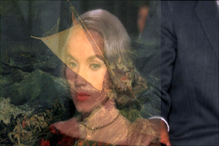

Portrait with a fly,
after North by northwest, A. Hitchcock, and Naufrage, W. Turner

Laurent Fievet's installations are an attempt to rediscover and define perfumes worn by several emblematic
Hitchcock’s film characters. As metaphors of the fascination generated by the image and its recalling power,
these fragrances explore in a different way the images of our cultural heritage, driving the spectator more deeply
into concealed stratifications of Hitchcock's shots and work.

His project includes now six installations.

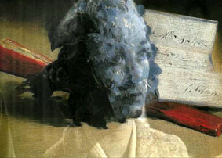

Portrait with violets,
after Psycho, A. Hitchcock, and E. Manet, Bouquet de violettes

The show to be presented in Galerie la Ferronnerie from february 14th till march 14th will feature,
with simplified versions, three out of the seven portraits of the serie Essences de l'image :
Portrait au narcisse (Portrait with narcissus), Portrait au bouquet de violettes (Portrait with violets)
and Portrait à l'hélice (Portrait with a fly). They have been conceived
from 2005 to 2006, and draw upon films realized during a five year period : To Catch a Thief (1955),
North by Northwest (1959) and Psycho, (1960).

