Galerie La Ferronnerie
Brigitte Négrier
40, rue de la Folie-Méricourt F-75011 Paris
+33 (0)1 78 01 13 13 / + 33 (0)1 48 06 50 84
www.galerielaferronnerie.fr
du mardi au vendredi : 14h-19h et samedi : 13h-19h
Membre du Comité Professionnel des Galeries d’Art
brigitte.negrier@club.fr

communiqué-invitation

Vittorio Roerade
Peinture, dessins

‘a kind of mushroom paradise’

vernissage samedi 15 décembre de 15h à 20h
exposition du 15 décembre 2007 au 19 janvier 2008

La galerie sera fermée du 21.12.07 au 3.01.08

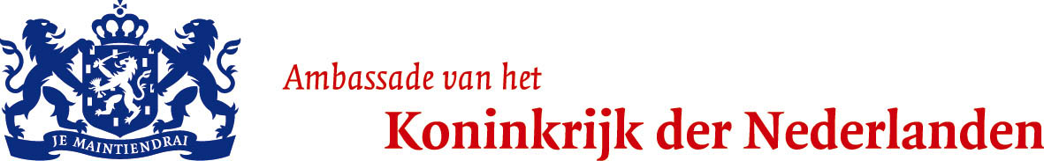 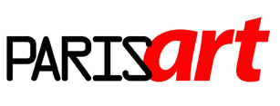 www.paris-art.com

Vittorio Roerade, peintre néerlandais né en 1962, à La Haye, utilise des techniques et matériaux peu orthodoxes …
Il associe la cire d’abeille, les collages, qu’il recouvre de résine …, il perfore ses travaux et décore ses images avec des cheveux,
de la broderie, des paillettes. Les principaux thèmes de ses peintures étranges, aux matières mouvantes évoquent la fragilité de la
vie humaine et les interconnections entre le genre humain et les autres espèces.
Pour l’exposition ’ a kind of mushroom paradise’ Roerade présentera un ensemble de nouvelles œuvres, peintures et dessins,
où ses recherches autour des ‘structures’ se développent.
Vittorio Roerade vient d’exposer au Groningen Museum (2007), et au GEM, Musée d’Art Contemporain de la Haye, solo (2006) Pays-Bas

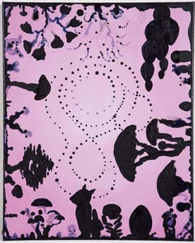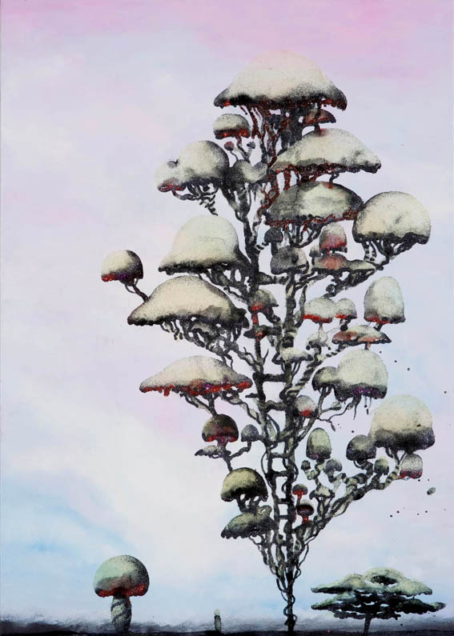

Vittorio Roerade, 2007 Vittorio Roerade, 2007
‘Mensenmensenmens’
Roel Arkesteijn
Curator GEM, Museum for Contemporary Art, The Hague (texte du catalogue ZOO, exposition solo de Vittorio Roerade au GEM, 2006)

‘Life, death and love’ – this is how Vittorio Roerade (1962), an artist from The Hague, Netherlands, once summarized the themes
of his work when asked about it. He touches upon large, romantic subjects, but does so in a light and almost casual manner. Take the small
Dubbelportret (Double Portrait) (2000), which is typical for Roerade’s painting if only for the unusual mixing of techniques. The painter combined
the millennia-old technique of encaustic painting with that of photo-collage. The result is a double portrait in an uncommon sense of the term:
a symmetrical pattern of two pairs of eyes and a mouth materializes under the surface in the blood-red painting constructed from thick layers
of beeswax. What at first glance appears to be a schematic portrait turns out to be a visual puzzle in which two different faces can be seen
simultaneously. It is an amorous painting, an expression of mutual connection. The figures flow into one another and share the same mouth.
They appear to kiss each other. The fleshy double portrait, with its piercing eyes, is sensual and moving rather than sinister. The delicate little
painting makes the vulnerability of the human being physically palpable. Once you know that the artist’s sister has passed away, you can never
look at the work in the same way again. Other so-called ‘wax portraits’ from the same period also form sensual, playful riddle. Some contain
larger constellations of eyes and mouths which do not only form portraits but kindle associations with stellar systems.

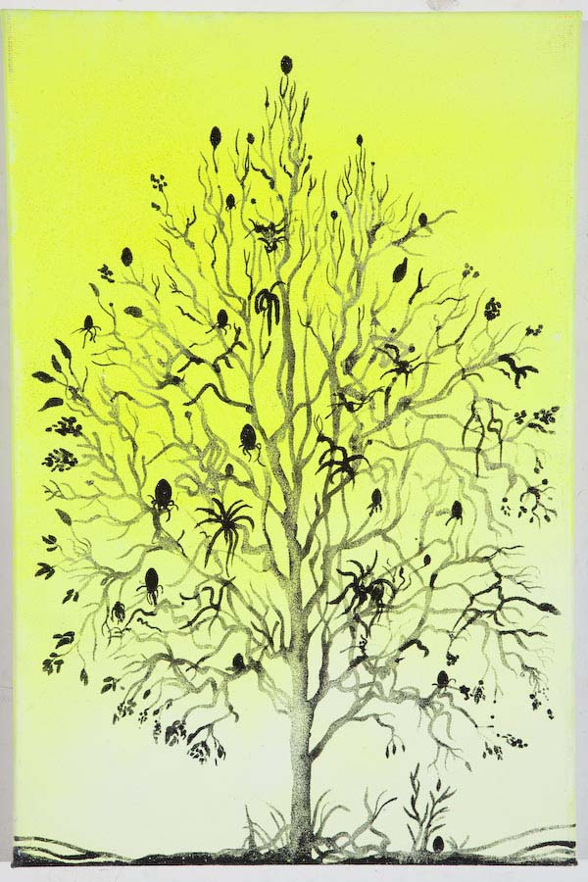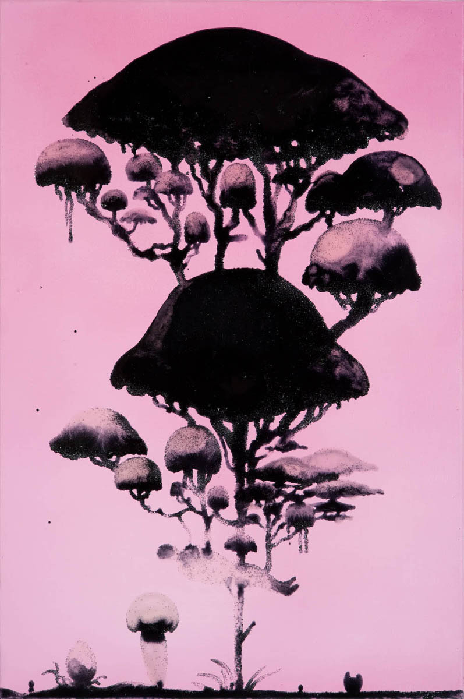
Vittorio Roerade, 2007 Vittorio Roerade, 2007

What makes Roerade such a remarkable artist is, in part, the great visual diversity of his work. In each new painting he seems
to re-discover himself. The thematic consistency in this abundance of expressive forms can be seen in Roerade’s first solo exhibition
at the GEM Museum for Contemporary Art in the Hague where, in the summer of 2006, Roerade presented work dating from 2000 onwards.
Using unorthodox techniques he repeatedly creates an associative, fairy-tale-like figuration. The ‘wax portraits’, for instance, were followed
up with panels that he painted, perforated, and covered with epoxy resin. The Wanderer (2004) is made up of a hallucinatory pattern of
thousands of drilled holes forming concentric circles. With some difficulty, one can discover text in this cosmos—in addition to the text
of the eponymous U2 and Johnny Cash song, there are also lyrics from Iggy Pop’s song The Passenger: ‘I am the passenger / And I ride and
ride / I ride through the city’s backside / I see the stars come out of the sky / Yeah, they’re bright in a hollow sky / You know it looks so good
tonight.’Recently Roerade has been preoccupied with quantum physics and chaos theories. The notion of connectedness, which had already
played an important role in his work, now took on a cosmic dimension. ‘We are all made of star dust,’ says Roerade. ‘The difference between
humans and animals is relatively small; all life is connected.’ While he had already regularly interchanged photo-collages of human eyes with animal
eyes in his wax portraits, now a real zoo of creatures made its appearance in Roerade’s paintings. The creatures are endearing things, somewhere
between people, fantastical beings, real animals, and plush toys. Often they are compositionally held together by a web-like structure which can
be interpreted as the ‘fabric of the universe’. A stylized form most reminiscent of Mickey Mouse or the man in the moon appears in the center of
The Wanderer, for instance. Roerade’s most recent paintings are large in size. More than ever, they are complex visual puzzles boasting a profusion
of motifs and composed from paint, embroidery, glitter, hair, epoxy, powdered metal, and pieces of wool.
Roerade belongs to a generation of ‘metro-painters’ who seem to form a gentle counterpart to the macho-painter violence of the ‘new wild’ artists
who made their mark in the 1980s. ‘Mensenmensenmens’ – ‘Peoplepeopleperson’ – is the programmatic title Roerade gave to one of his works and
to his exhibition at the GEM. An almost child-like amazement about life and human relations lies at the basis of his work. Roerade’s curiosity is perhaps
best seen in his sketch books, which form the linking factor between everything he creates. In countless delicately-drawn notes, he makes observations,
connects motifs, feels out possibilities for future works, and reports on existential doubts and everyday worries. Each work by Roerade can be conceived
of as a cosmos unto itself that the viewer can roam around in like an explorer. His paintings have an unabashed, exuberant beauty and appeal to empathy
-qualities which, for a long time, were considered ‘not done’ in visual art. Roerade’s universe is permeated by a Lust for Life, to use Iggy Pop once again,
which is infectious when you try to penetrate it.’

Roel Arkesteijn
Curator GEM, Museum for Contemporary Art, The Hague

+ d’informations : brigitte.negrier@club.fr

+ d’images : www.galerielaferronnerie.fr

Actualités

A venir à la Galerie la Ferronnerie :

> à partir du 19 janvier 2008, ‘des Aires’, avec
Henni Alftan, Solenne Goupil, Nicolas Tourre
> au printemps :
La saison finlandaise, 100% Finlande, avec un solo de Sanna Kannisto

Les expositions hors galerie :

> Le 12 décembre Laurent Fiévet participe à une performance au musée Munch (Munch Museet)
Oslo, Norvège, In/out, en collaboration avec la danseuse norvégienne Johanna Zwaig
> 17.11.07 au 20.12.07 Sanna Kannisto, Bird Watching, Centre d’art Vishal, Haarlem, Pays-Bas

> 19/09/07 au 6/01/08 Juan Pérez Agirregoikoa à la Biennale de Lyon, artiste invité par le commissaire Peio Aguirre

