Galerie La Ferronnerie
Brigitte Négrier
40, rue de la Folie-Méricourt
F-75011 Paris +33 (0)1 78 01 13 13
www.galerielaferronnerie.fr
Membre du Comité Professionnel des Galeries d’Art

8 – 12.02.17 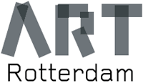 Stand 61 - Van Nelle Fabriek, Rotterdam NL

Frédéric Coché, Laurent Fiévet, Natasja van Kampen, Sanna Kannisto, Jérôme Touron

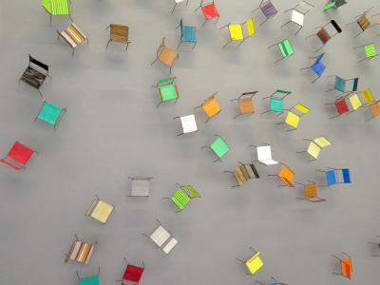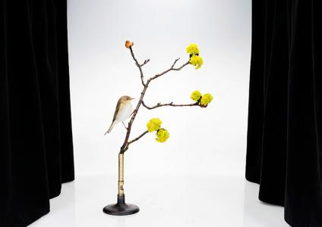

Jérôme Touron, 2016 Après la nuit, devant le ciel 125x175 cm Sanna Kannisto, Phylloscopus trochilus, 2015

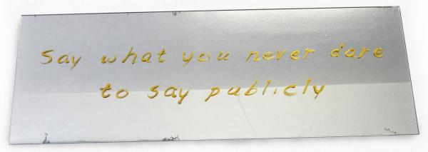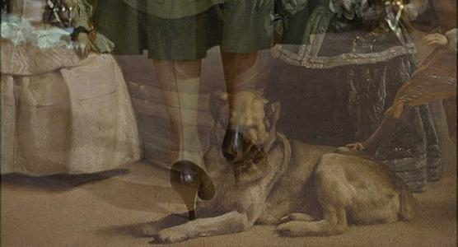

Natasja van Kampen, Say what you never ..2015 Laurent Fiévet, Carlotta’s way, video editing 93min

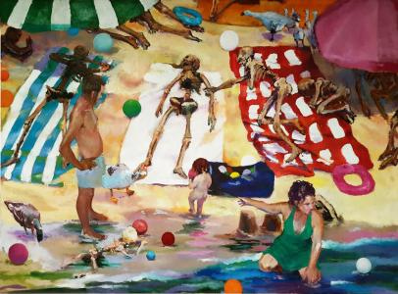

Frédéric Coché, La plage, 2016, oil on canvas, 140x190 cm

Galerie La Ferronnerie
Brigitte Négrier

Frédéric Coché (Pont à Mousson, France, 1972) uses painting, drawings etchings to build artworks dealing with Human destiny ; For Art Rotterdam, the gallery will exhibit the big canvas ‘La plage’ (Beach) where besides the contrast between the peaceful family life, the baryards animals and the ‘animated’ skeletons, Frédéric Coché introduces other reading clues : the bath towels are the colours of french flag, and they are alos like a glimpse to some famous artists like Buren or Viallat , then the coloured ballons could be quoting Damien Hirst spot or Baldessari dots of colour
He has works in Museums, such as Musée of Art and History, Geneva (Ch) Musée des Beaux-Arts de Nancy, France etc..

Jérôme Touron works with galerie la Ferronnerie since 1992, he will present an important New piece
Après la nuit, devant le ciel (After the night in front of the sky). The artist’s works could be considered as post-minimalist but the spirit he put in it give poetic touch, sometimes he likes to add touch of humour. His works are in important private collections, he also got a grant from the Krasner-Pollock
Fondation.

Laurent Fiévet creates video editing from famous movies, such as the piece we will show at ART Rotterdam 2017, to which he sometimes add some elements, thus elaborating installations.
Carlotta’s Way (2014) and Returning Carlotta’s Way (2014) bring together a short extract from Vertigo by Alfred Hitchcock, highly slowed down and reworked by plays of ebb and flow, and a series of details from Las Meninas by Diego Velasquez through overlay effects.
Although the titles of the montages echo the Brian de Palma Film Carlito’s Way, which proposed many returns to the work of Alfred Hitchcock, they chiefly introduce a reference to the character of Carlotta Valdes, whose painted portrait plays a key role in the scenario of Vertigo. Presiding over multiple links between fictional and pictorial worlds to the point of generating many figurative and temporal overlap effects, it invites the characters in the story and viewers of the film to make comparative approaches that are similar in nature to those instigated by the montages through combining cinema and painting.
Laurent Fievet videos are exhibited in France –private and public institutions for example
Carlotta’way was exhibited at the re-opening of Musée Picasso-Paris (2014) after having been exhibited at Galerie la Ferronnerie for the 1st time ever.

Sanna Kannisto (Finland) explores nature through photography, creating staged photos.
‘…My work explores the relationship between nature and culture. In my artistic work I aim to study the methods, theories and concepts through which we approach nature in art and in science. As an artist I am attracted by the idea that when I am working in a rain forest I am a ‘visual researcher’.
Taking photographs in a field studio has become one of my most important working methods… t. …When the object has been taken out of its original setting - out of nature - it becomes special. The aspect of a white background that suggests scientific recording and documentation interests me.
These compositions in the field studio have also allegoric nature. For me photography is a medium, which in itself documents the transience of life…’

The singularity of her works has led Centre Pompidou, Paris to buy some of her works, besides many other private and public institutions around the world

Natasja van Kampen living and working in Den Haag, likes with her artworks to underline how power
Interferes in citizens lifes, wether in the contemporary world or through quotations to the past.
Natasja van Kampen is constantly aware of the need for balance between good and evil.
During Long-term drawing projects, she explores the elusiveness and the insanity of power. Her drawings are sometimes three dimensional, and often of monumental large size.
She will be the the focus artist for Galerie la Ferronnerie at Drawing Now Paris 2017.

For more infos and images please contact Brigitte Négrier
bn.ferronnerie@gmail.com

www.galerielaferronnerie.com

